Graded assignment 2 – 4 credit students only

Implement a classical conditioning network and test it.

1. Use the receptive fields you created for assignment 1 or create a new version. You want 4 receptive fields similar to these

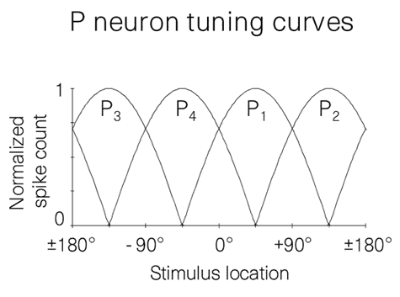

1. First we will use the normalized spike count for each neuron at a given stimulus as output instead or transforming into spikes. Create a small network in which each of these sensory neurons forms an excitatory synapse with a single postsynaptic neuron. This postsynaptic neuron (NP) also receives a reward signal of amplitude 1.0 when on and 0.0 when off.



1. You want to make NP a linear threshold neuron (x=0 when I < threshold, x = I when I => threshold). Choose a set of parameters (synaptic weight, threshold) that allows NP to respond to reward but not sensory input. Note the parameters.
2. Now create a Hebbian learning rule that changes the weights from the sensory neurons to NP when reward is present. Run this learning rule for 10 steps with a specific angle of stimulation (update the weights and NP at each step). Note the angle and plot the output of NP as well as the four synaptic weights for these 10 steps.
3. Using the synaptic weights that resulted from (b), plot the tuning curve of NP over the whole range of angles (with reward = 0)
4. Explain what you see and why.
5. What you need to obtain is a network in which synaptic weights increase enough during the learning phase enough for the angle you trained with to allow NP to cross above threshold.
6. Repeat this exercise two more times using different parameter sets (learning rate, threshold ..). Plot the results each time and discuss what you see.
7. Repeat the same exercise using a learning rule that includes a threshold above which a weight is increased and below which it is increased. What do you conclude?